UBND THÀNH PHỐ HỒ CHÍ MINH | CỘNG HÒA XÃ HỘI CHỦ NGHĨA VIỆT NAM
TRƯỜNG CAO ĐẲNG LÝ TỰ TRỌNG | Độc lập - Tự do - Hạnh phúc
THÀNH PHỐ HỒ CHÍ MINH
ĐỀ THI KẾT THÚC HỌC PHẦN LÝ THUYẾT
HỌC KỲ: I NĂM HỌC: 2018 – 2019

Bậc đào tạo: TRUNG CẤP Học phần: NGHE
Lớp: 18T4-………… Ngày thi: ___ / ___ / 2018
Thời gian thi: 45 phút (không kể thời gian phát đề)

HỌ VÀ TÊN SV |  | Chữ ký Giám thị I | Chữ ký Giám thị II | Số mật mã
LỚP | SỐ KÝ DANH | Chữ ký Giám thị I | Chữ ký Giám thị II | Số mật mã
--------------------------------------------------------------------------------------------------------------------------
Chữ ký Giám khảo I | Chữ ký Giám khảo II | ĐIỂM BÀI THI |  | Số mật mã
 |  | (bằng số) | (bằng chữ)
1. Hướng dẫn làm bài
Đề số 001

Thí sinh không được sử dụng tài liệu khi làm bài.
Sinh viên làm bài ngay trên đề thi.
Bài thi này gồm 40 câu, mỗi câu 0.25 điểm.

2. Nội dung đề thi

Task 1: Listen. What do people do to celebrate?
Match each celebration with an activity. Listen two times. (1.5pts)

- ______ St.Patrick’s Day a. visit graves
- ______ Moon Festival b. go to concerts
- ______ Bob Marley Day c. share special lunches
- ______ Day of the Dead d. wear special clothes
- ______ Kartini Day e. go to a parade
- ______ St. Lucia’s Day f. eat special cakes

--------------------------------------------------------------------------------------------------------------------------------------------------
Task 2: Listen. Why does each people like the item?
Circle the correct information. Listen three times (1.5pts)
- a. She wears it everyday. 4. a. It’s cheap.
b. The sun hurts her eyes. b. It’s not easily seen.
c. It’s good for windy days. c. She likes the colors.
2. a. It’s made of plastic. 5. a. It doesn’t have wheels.
b. It’s small. b. It’s good for travelling.
c. It’s great for work. c. It’s very big.

3. a. It’s small. 6. a. They’re comfortable.
b. It’s big. b. They’re new.
c. She uses it while she runs. c. He likes the color.

Task 3: Some guests are talking at a party. What are they talking about?
Listen and circle the correct answers. Listen three times. (2pts)

- a. The woman is having a good time. 5. a. The man is hungry.
b. The woman is not enjoying herself. b. The man does not want anything to eat.
c. The guests are unfriendly. c. The man wants to drink.

2. a. Jim does not recognize the singer. 6. a. The man took a train across the U.S.
b. Jim does not like the singer. b. The man never travels.
c. Jim likes the singer. c. The man recently took a trip.
3. a. The man knows the guest. 7. a. The woman’s mother is not working now.
b. The man has not met the guest yet. b. The woman has a job now.
c. The man does not want to meet the guest. c. The woman’s mother has a new job.

4. a. The man does not work now. 8. a. The man knows a lot of people at the party.
b. The man is not busy now. b. The man does not know a lot of people at the party.
c. The man is very busy now. c. The man knows everyone at the party.

---------------------------------------------------------------------------------------------------------------------------------------

Task 4: Listen. You will hear a traditional folktale.
Number the pictures from 1 to 6. Listen three times. (1.5pts)

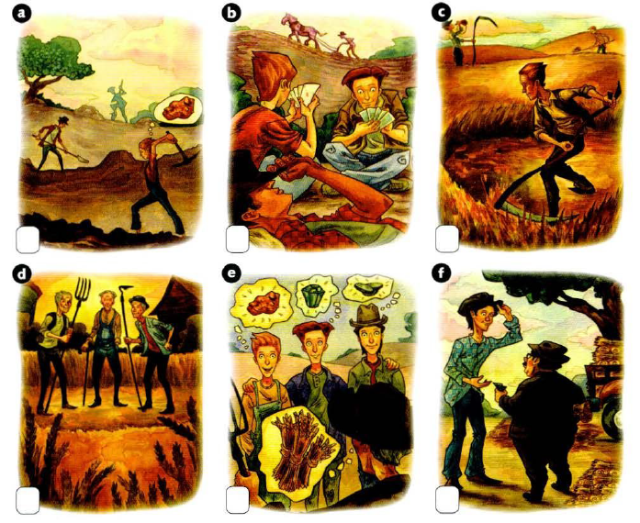

----------------------------------------------------------------------------------------------------------------------------------------
Task 5: Listen to people describing about a health problem to a friend.
What phrases complete each statement? Circle the correct answer. (1pt)

- Lately, she ____________. 3. She gets very bad _____________.
- easily falls asleep. a. backaches
- can’t fall asleep. b. headaches
- sleep all night. c. pains in her eyes.

- Lately, he doesn’t ____________. 4. He’s getting a lot of _____________.
- take any vitamins. a. toothaches
- feel tired. b. stomaches
- have any energy. c. colds

Task 6: Listen and fill in the blanks. Listen three times (2.5pts)

In many countries, this (1) _______________ is popular. In Korea it has a (2) _______________ meaning. In the first half of January, many Korean boys fly kites. On January fifteenth, they write: No bad luck - on their kites and fly them very high in the (3) _______________. The kites fly away. They believe it (4) _______________ the bad luck away for the year.

Many countries have holidays to (5) _______________ good luck. In Thailand, people (6) _______________ this festival. The festival takes place (7) _______________ in Thailand, but is especially popular in the north. Water Festival takes place in the middle of April. It is part of the Thai New Year. People throw buckets of water on each other. There are even (8) _______________ where people throw water. It is especially (9) _______________ to pour water on older people. Its (10) _______________ respect.
______Hết_______
GHI CHÚ: CÁN BỘ COI THI KHÔNG ĐƯỢC GIẢI THÍCH GÌ THÊM.

KT.TRƯỞNG KHOA GIẢNG VIÊN RA ĐỀ

Phạm Thị Thu Nga Nguyễn Thị Bảo Trân

